**3d Reconstruction from Multimodal Satellite Data**

**A) Problem Statement**

**Definition:**

Satellite data which has found its applications in different domain is an emerging field having great potential applications. New high-resolution satellite images such as those from IKONOS (an earth satellite) provide potentially useful information for the identification of individual surface objects as compared to the previously provided satellite images. This enlarges the researchers’ circle of researching and provides the space for reconstruction of these objects into 3D models.

Hence, the problem statement states the conversion of the given or obtained satellite data into high-quality 3D objects. The method that will be used for 3D reconstruction must be an automated method for the recovery of the desired target sources viz. the maps, buildings, objects etc. through the high-resolution satellite images.

**Challenges:**

There are many factors which come up as the major challenges while working with satellite data. These factors are:

1. Image resolution and quality
2. Matching template size
3. Offset of the reference frame between image and map data
4. Acquisition time difference between images used and digital maps etc.

These all factors disturb the accuracy rate of the model and hence, inaccurate reconstruction deteriorates the quality of the devised model.

**Scope:**

3D reconstructed models of satellite imagery can have great implications in various fields with some useful applications which are listed below:

1. Three-dimensional models of cities
2. Automatic Building reconstruction
3. Deriving a Soil Map from a Digital Elevation Model
4. Water Pipes and Very Detailed GIS Soil Environments
5. Soil Environment Mapping
6. Mapping Soil Drainage with Satellite Imagery
7. Mapping Natural Assets (trees and vegetation)

**B) Background**

Previously, many researchers have deployed various 3D reconstructed models based on Satellite imagery. These works include the approach that fuses multiple depth maps derived by stereo matching to generate high-quality 3D maps, an automated method for building height recovery through the integration of high-resolution satellite images and digital vector maps, approach to the reconstruction of three-dimensional models of cities from satellite images, Automatic 3D Reconstruction from Multi-date Satellite Images, Efficient and Automated Multimodal Satellite Data Registration through MRFs and Linear Programming etc.

**C) Methodology**

Architecture of the 3D Reconstruction Model from multi-model satellite data is shown in Figure 1.

3D- Reconstruction Model

Satellite Imagery

**Input**

Training &

Experimentation

**Output**

Object

Recovery

[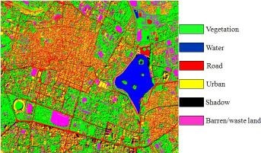](https://www.google.com/url?sa=i&rct=j&q=&esrc=s&source=images&cd=&cad=rja&uact=8&ved=2ahUKEwj1p825nuXaAhVHLo8KHYV9AvEQjRx6BAgBEAU&url=https://sites.google.com/site/jsenthilnath/research-projects/uav-applications&psig=AOvVaw2fFEbYePC-WjJfKGwoftot&ust=1525288972898750)

Satellite Imagery Database

**Imagery Pre-Processing**

Figure 1: Architecture Diagram of 3D Reconstruction Model

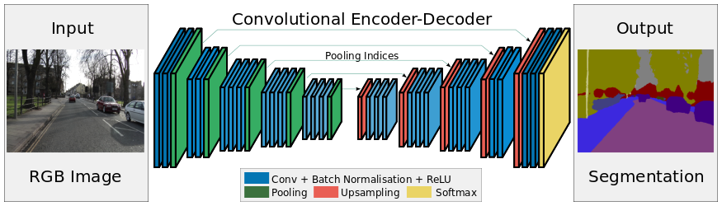

Figure 2: Dare, P. M. (2005). Shadow analysis in high-resolution satellite imagery of urban areas. *Photogrammetric Engineering & Remote Sensing*, *71*(2), 169-177.

The methodology involves 3 important steps for the 3D reconstruction of satellite images.

**Step 1: Processing of Satellite Images**

In the first step, satellite images are processed to obtain important local features such as SURF and SIFT features. This step further involves seed points selection, gridding, resampling, normalized DEM construction and image features correspondence.

**Step 2: Detection of Objects**

Second stage detects and recovers the object in the 3D model. This step involves following sub-stages: Image Matching, Positional properties check and model construction.

**Step 3: Object Recovery**

Third step recovers the objects using 3D reconstruction model.

**D) Experimental Design**

**Datasets:**

1. US based Digital Globe is currently operating three satellites: QuickBird, WorldView -1 and WorldView-2. ([www.digitalglobe.com](http://www.digitalglobe.com/))
2. US based GeoEye is currently operating three satellites: GeoEye-1, IKONOS and OrbView-2. ([www.geoeye.com](http://www.geoeye.com/))
3. French based Spot Image is currently operating two satellites: SPOT 4 and SPOT 5. ([www.spotimage.com](http://www.spotimage.com/))
4. German based RapidEye is currently operating five satellites: RapidEye 1-5. ([www.rapideye.de](http://www.rapideye.de/))
5. Netherlands Antilles based ImageSat is currently operating two satellites: EROS A and EROS B. ([www.imagesatintl.com](http://www.imagesatintl.com/))

**Evaluation measures:**

Measures such as Root Mean Square Error (RMSE), Mean Average Precision (MAP) and Accuracy will be computed by comparing the depth of images of objects taken from different angles at different time from satellites.

**Software and Hardware requirements:**

The following are likely used technologies for the proposed work to solve the problem:

1. Libraries such as OpenCV, TensorFlow and Keras, which provide real-time computer vision and machine learning software library.
2. Python that is an efficient and debugging programming language.
3. Training will be conducted on NVIDIA GPUs for training CNN based 3D Reconstruction Model